**Abstract: -**

The aim of this project is to simplify the exam supervisor allotment process in our college. Currently this is done manually by one person who assign duties to staff members for required time(slots). Here the staff members can not select slot of their choice.

So here we built a platform where staff members can reserve slots at their own will.

**Implementation:-**

Our product consists of two working softwares. One is web app and other is an android app. Team of two people have worked parallelly on both them. This report is concerned only on android app. There will be separate report for web app.

**Requirements to build the app:-**

**Hardware requirements: -**

1) Computer with min specs as follows:-

* Microsoft® Windows® 7/8/10 (32- or 64-bit)
* 3 GB RAM minimum, 8 GB RAM recommended; plus 1 GB for the Android Emulator
* 2 GB of available disk space minimum,  
  4 GB Recommended (500 MB for IDE + 1.5 GB for Android SDK and emulator system image)
* 1280 x 800 minimum screen resolution

2) Android device having minimum specs as:-

* Android ver 4.4 Kitkat (API level 19)
* 1GB RAM
* 20 mb of free space
* Internet Connectivity

**Software requirements: -**

* Android studio version 3.3

**Requirements to run the app:-**

Android device having minimum requirements as follows:-

* Android ver 4.4 Kitkat (API level 19)
* 1GB RAM
* 20 mb of free space
* Internet Connectivity

**App design:-**

The app app is meant to be used by two type of people first one is called *admin* and second is called *user*. The admin has power to create form, add members, remove members and admin remove admin. The user can only view the currently available form and fill them.

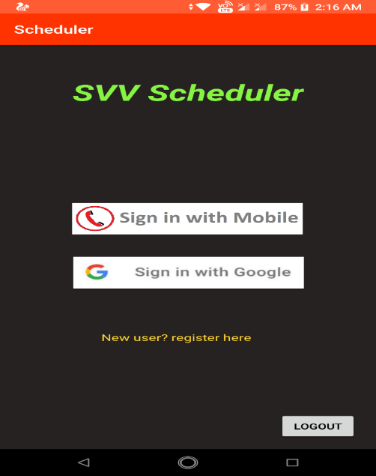**Login Page:-**

the user can login with their Google ID or else can register with Google account if not already done.

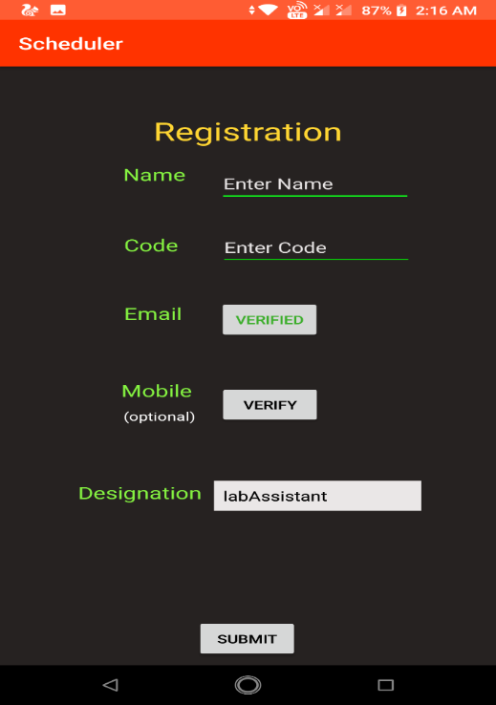**Registration page:-**

This includes field for the name code, email, address, mobile number and designation. Designation includes four options professor, associate, assistant, lab assistant. phone number has to be an Indian number and the code represents the unique three or four letter word assigned to the staff member by the college

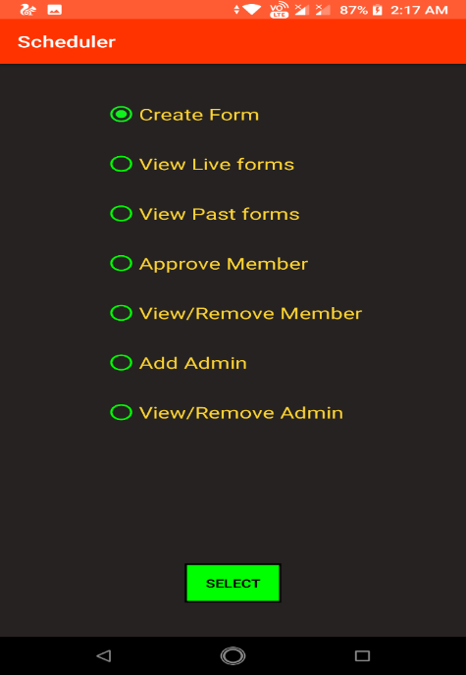

**Admin:-**

**Admin Main menu:-** this page has 7 options:-

1. Create form:- it will lead to form creation page
2. View live forms:- if shows forms which are within due date
3. View past forms:- it shows form which are past due date
4. Approve member:- it shows the list of the people who have put request for membership
5. View member:- show the list of current members
6. Add admin:- it is used to add new admin to the app
7. View admin:- it shows list of the all admins

**Form creation:-**

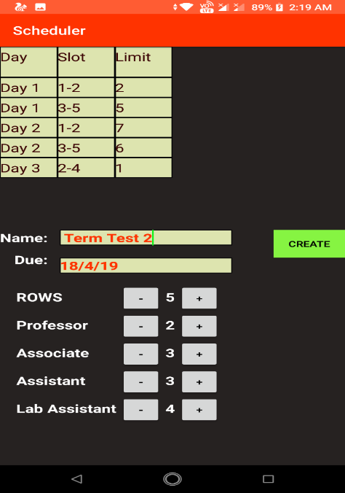This page is used to create the form. It has common fields like name of the form, due date, number of rows, number of slots assigned to professor, associate, assistant and lab assistant and obviously button to create form.

The form itself looks like a table with 3 columns and n number of rows whereas three columns represent Day, Slot and limit. the column ‘Day’ represents each day of the exam for example Monday, Tuesday and so on. The column ‘Slot’ is used to represent the slots available at that day. It can also be used to represent the exact time of the exam. So basically it is just a label to identify the the slots. The column limit represents number of people required for the corresponding slot on the corresponding day. Does it represents the net manpower required at a particular time.

Each designation has to be a assigned a number representing the total number of choices to be filled by that person of that designation. For example if you expect an associate professor to have three duties for the upcoming exam then and you can assign the number 3 to the associate professor while creating the form.

After you have successful filled all the fields then you can click the create button to proceed form creation process. if everything goes as expected then you must get a toast message saying that your form has been created successfully

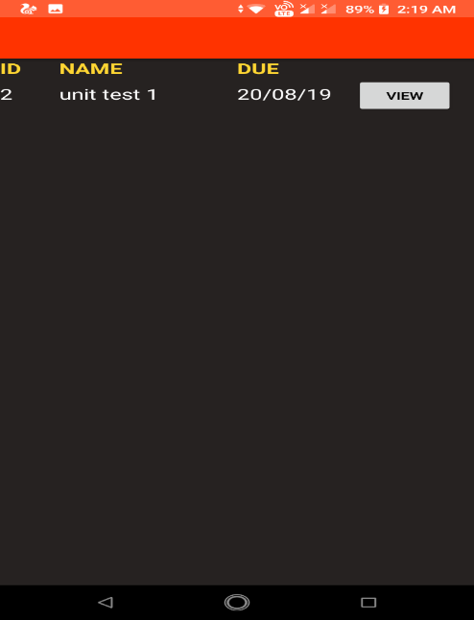

**Live Form:-**

This page has all the form which are within the due date. It is basically a list with four columns and n number of rows. Where each row represents a form. Four columns represent ID, name, due date and a button to fill form. is hair ID is a unique number representing the form. Content of form can be viewed by clicking the view button present at the right side of each row.

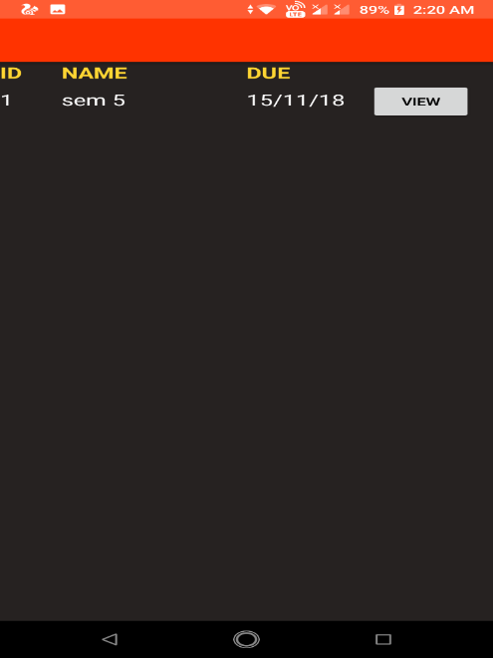

**Past Form:-**

This page has all the form which are past due date. It is basically a list with four columns and n number of rows. Where each row represents a form. Four columns represent ID, name, due date and a button to fill form. is hair ID is a unique number representing the form. Content of form can be viewed by clicking the view button present at the right of each form.

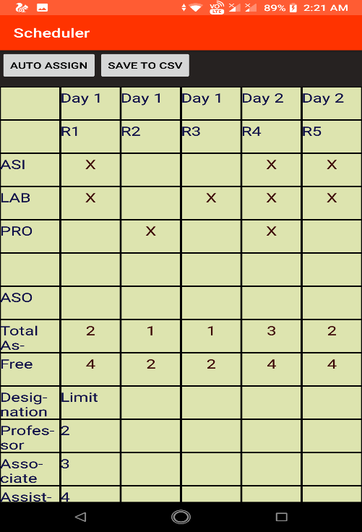**Form Grid:-**

Stage the live status of a form. It is a big table were column represent the the day and corresponding slots and rows represents members. people were filled the form I represented at the top and people who have not filled the form yet I represented below them. corresponding slots are marked if there are selected by the corresponding members.

below them there are two rows representing total number of people available for that slot and free slots.

Below it there is a table representing the number of of slot limit assigned to each designation.

Above the form there are two buttons called ‘auto assign’ and ‘save to csv’. ‘auto assign’ button is used to to auto assign the remaining form fields to members who have not filled the form yet and ‘save to csv’ button is used to save the form in the csv format in the local hard drive.

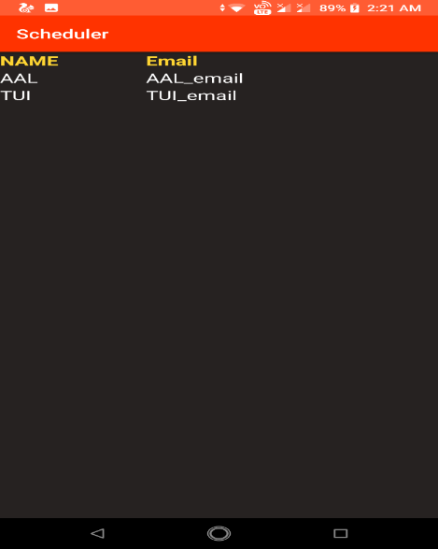**Approve Member:-**

This page has list of people who have requested for the membership. It has two columns representing name and email address. You can click on the corresponding name to add the requested person to the member list. On clicking the name of the person you should get a popup for your confirmation and. On successful confirmation the corresponding person will be added to the member list and the current page will be updated automatically.

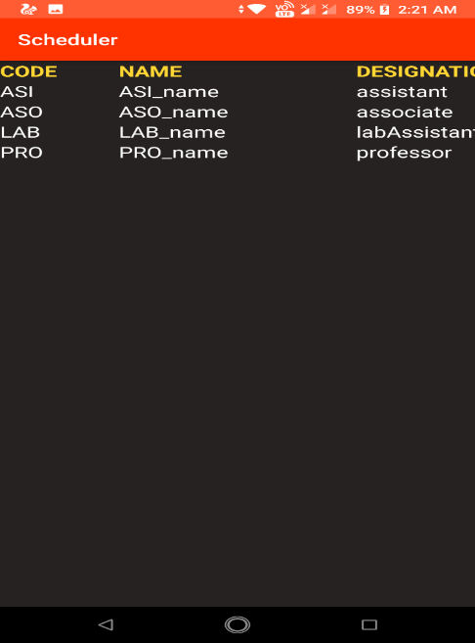**View Member:-**

This page has list of all members registered with this app. It has 5 columns representing the code, name, designation, email and mobile number. If you want to remove phone number from this place then click on the corresponding code of that member. you should get a popup message for your confirmation. On successful confirmation the corresponding member will be removed from this list and the current page will be updated automatically.

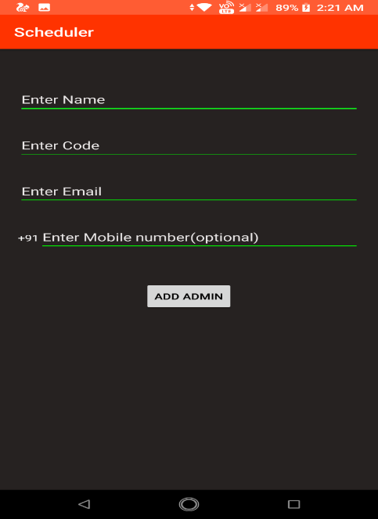**Add Admin:-**

This page is used to add admin to this app. It has four fields representing the name, code, email and mobile number. Also there is a button to add the admin to the database.

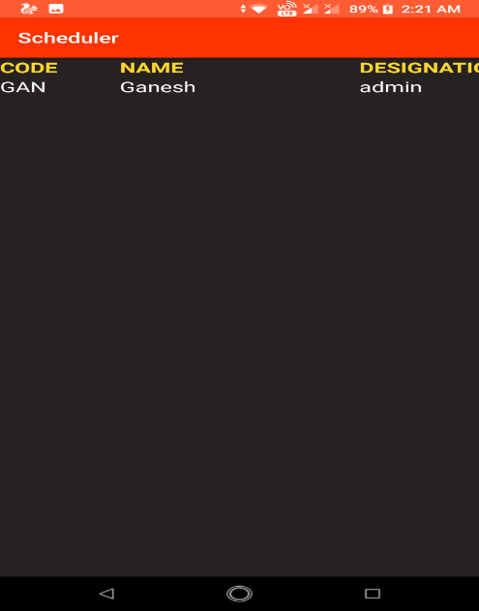**View Admin:-**

This page has list of all admins registered with this app. It has 5 columns representing the code, name, designation, email and mobile number. If you want to remove phone number from this place then click on the corresponding code of that member. you should get a popup message for your confirmation. On successful confirmation the corresponding member will be removed from this list and the current page will be updated automatically.

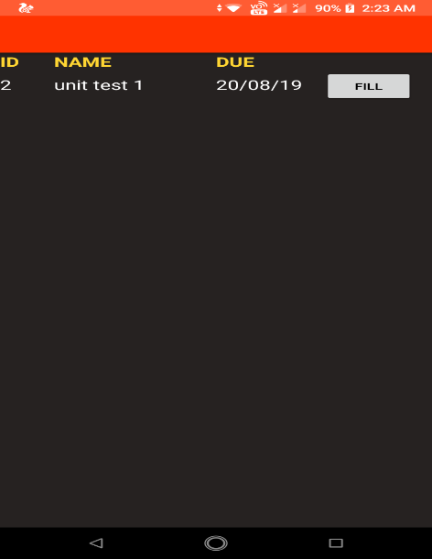**User:-**

**User Forms:-**

This page has all the form which are within the due date. It is basically a list with four columns and n number of rows. Where each row represents a form. Four columns represent ID, name, due date and a button to fill form. is hair ID is a unique number representing the form. Content of form can be viewed by clicking the view button present at the right side of each row

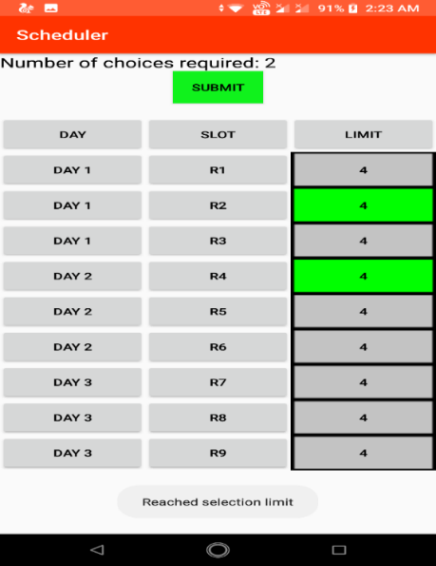**User Grid:-**

This page has three columns and and n number of rows. Here each row represent 1 slot. three columns represent day, slot and limit. Here days and slots are labels entered during form creation process. and limit represents the number of people required for the corresponding slot.

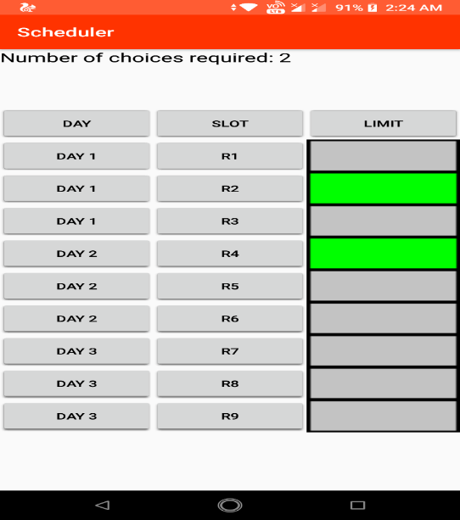 on the top of the form the number of choices to be filled is displayed. this number is decided based on the designation of the signed in user.

Here user is supposed to click on the the slot which they want to reserve for themselves. however there are certain conditions. One can only reserve the slot if it has number of free slots at least 1 and it should not be consecutive to a slot which is already reserved by themselves. reserve slots are represented in green colour. Slots which are unavailable are represented in red colour. you can sleep on on the reserves slots to unreserve it as long as you have not submitted the form. After you successfully selected your preferences you can click the submit button to reserve those slots for yourself but remember that you can only click the submit button if you have the total number of choices selected is equal to the number displayed above the table. After successfully submitting the form the submit button will disappear and and you won't be able to edit the form again. However you can come back again to check the result slots.

**Database:-**

We have used Firebase realtime database to store our app data for android app. It is an NoSQL database. The free version of firebase supports 1GB of storage, 100 concurrent connections, 24hrs uptime, realtime updates and many more features.

Structure of the database is shown on the next page.

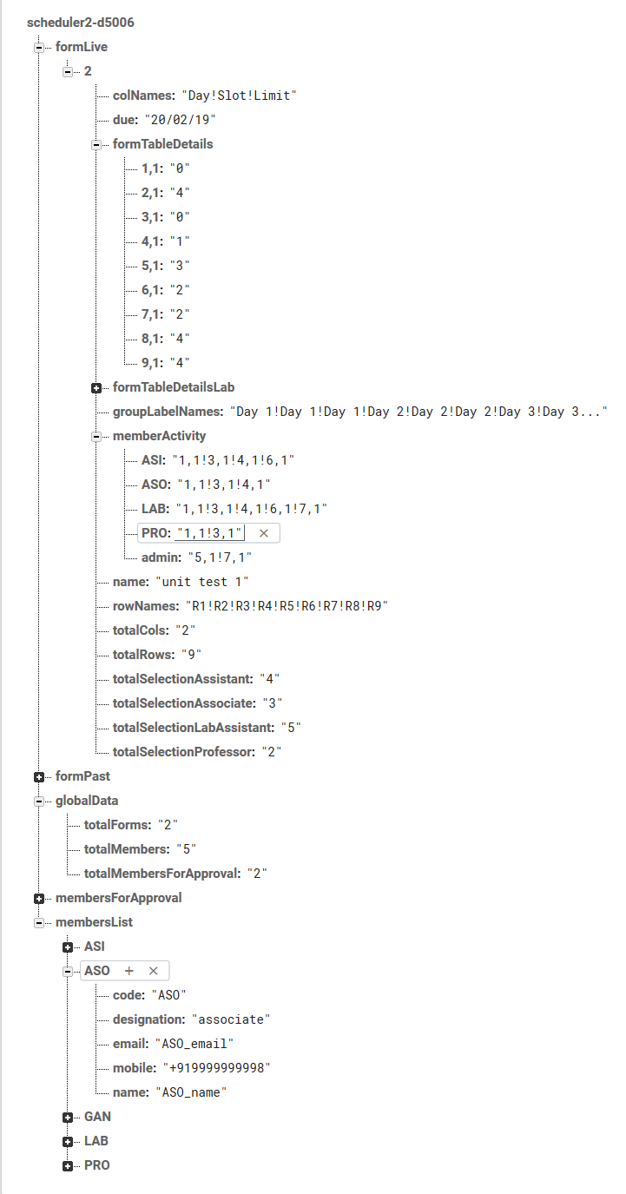

The hierarchy is pretty much self-explanatory. Each form is just couple of entries in the database which hardly takes any space. Our database was about 9kb which has 5 user accounts, 4 forms. Even in real life scenario our prediction is that the 1GB database can sustain load of about 1 million forms and thousands of users accounts easily.